Homework #4: Multicore Programming

Dayanara Lebron Aldea

STA 141C: High Performance Computing

*Task: Compare your run-time with the original one.*

I used my personal computer to run this, below is a screenshot of my run-time and accuracy and the original single threaded and its accuracy. The times achieved are machine-dependent, in my computer the original script took ~199s to run compared to 79.8s with the 4-core paralleled code. This represents a 60% decrease in running time, making it about 2.5 times faster. Accuracies remained the same.

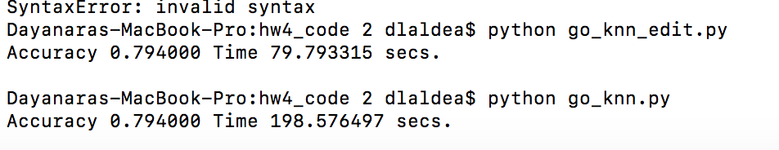

*Snippet of Code:*

Since the knn is done for each testing sample, and we needed to divide the calculations in 4 core processes; I divided the testing data in 4 subsets, making each set a parallel job. Each job calculates the amount of correct predictions and at the end we sum all correct predictions across processes and compute the accuracy. Below how I parallelized the code:

def go_nn(Xtrain, ytrain, Xtest, ytest):

def knn_per_proc(start, finish,output):

correct =0

for i in range(start,finish): ## For all testing instances

nowXtest = Xtest[i,:]

### Find the index of nearest neighbor in training data

dis_smallest = np.linalg.norm(Xtrain[0,:]-nowXtest)

idx = 0

for j in range(1, Xtrain.shape[0]):

dis = np.linalg.norm(nowXtest-Xtrain[j,:])

if dis < dis_smallest:

dis_smallest = dis

idx = j

### Now idx is the index for the nearest neighbor

## check whether the predicted label matches the true label

if ytest[i] == ytrain[idx]:

correct += 1

output.put(correct)

#Parallelize

n_processes=4

n_items=Xtest.shape[0]

#Calculate number of items per process

i_pp=(n_items+n_processes-1)/n_processes

output=mp.Queue()

#Calculate starting and stopping points in data

stop=[(i,min(n_items,i+i_pp)) for i in range(0,n_items,i_pp)]

#Create processes

processes=[mp.Process(target=knn_per_proc, args=(t[0],t[1],output)) for t in stop]

#Run processes

for p in processes:

p.start()

#Exit the completed processes

for p in processes:

p.join()

# sum of correctly predicted per process

correct=sum([output.get() for p in processes])

acc = correct/float(Xtest.shape[0])

return acc